Devon Beekeepers need your help as they prepare for Action against the Asian Hornet
6th – 12th September 2021

Devon Beekeepers’ Asian Hornet Action Teams (AHATs) are responding to help stem the threat from the Asian hornet which has swept through Europe and is now in the Channel Islands.

The Asian hornet (Vespa velutina) is native to Asia. It is believed that it was accidentally imported into Southern France from China (2004) and has spread rapidly through France and into neighbouring countries.

Tiverton Beekeepers branch (TBKA) will be joining with other UK AHAT teams for the National Asian Hornet Watch Week running from:
6th - 12th September 2021.

AHAT’s are encouraging members of the public to be on the alert for Asian Hornets until the end of October. An excellent place to look out for them is on Ivy, coming into flower over the next few weeks, or fallen fruit and your garden. Also returning from France, Spain or the Channel Islands please look for Asian Hornet stowaways in caravans, motorhomes, tents, camping equipment, trailers and boats.

Members of the public can download the free Asian Hornet Watch App on their smartphone to assist with identification and quick submission of any reports.

TBKA AHAT Coordinator, Gavin Nuttall-Owen, reminds that the Asian hornet is a threat to all pollinators (solitary bees, hoverflies, bumble bees, butterflies and moths) and not just honey bees. The following characteristics are useful for an accurate identification:
- smaller than our native European hornet
- 25-30mm head to tail,
- orange face
- thorax dark brown or black and velvety
- a dark abdomen with the 4th segment / band being yellow orange.
- bright yellow lower legs.

- doesn’t fly at night, unlike our native European hornet (Vespa crabro),

The public should be aware that whilst the Asian Hornets are not ordinarily aggressive, they are advised that they should not under any circumstances approach a nest. If they are disturbed, they will actively defend their nests.
Malcolm Crook, TBKA Chair, explains that nests are usually found high in trees but they are now starting to be found low down in garden shrubs, undergrowth, roadside banks or even underground in Jersey. One was found in a shrub outside a house dining room window! Blundering into such nests without protection has led to a number of fatalities on the continent from adverse reactions to the insect’s venom from multiple stings.

Thwarting its establishment here in the UK is crucial to protect our native pollinators, UK flora, fruit and other insect pollinated crop production

For this reason, we are asking everyone, to learn how to identify this non-native species from the other flying insects we usually see at this time of year.

The Asian Hornet Watch week will run from the 6th to 12th September 2021 and AHAT members are asking the public to be attentive and to report any sightings

See it, Snap it, Send it
Nationally
- by email at alertnonnative@ceh.ac.uk
Action can only be taken if photographic or physical evidence is provided.

- The Asian Hornet Watch App can help you report a sighting https://play.google.com/store/apps/details?id=uk.ac.ceh.hornets&hl=en_GB or
https://apps.apple.com/gb/app/asian-hornet-watch/id1161238813
Locally
- Contact the TBKA AHAT directly: ahat@tivertonbeekeepers.uk
they will be pleased to help you with identification and also advise on the reporting procedure – photographic evidence gets a speedy response or physical specimen

For more information:
  - Non-Native Species Secretariat (NNSS)
  - http://www.nonnativespecies.org/alerts/asianhornet
  - https://tivertonbeekeepers.uk/ Tiverton Beekeepers

Editors: PLEASE NOTE
Please use any of the photos shown below to ensure that the correct insect is published.
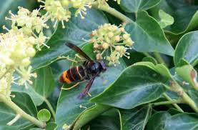
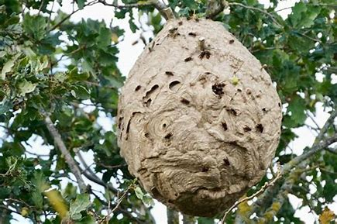
Asian Hornet feeding on Ivy Picture from BBKA
Picture from Dungeness Bird Observatory
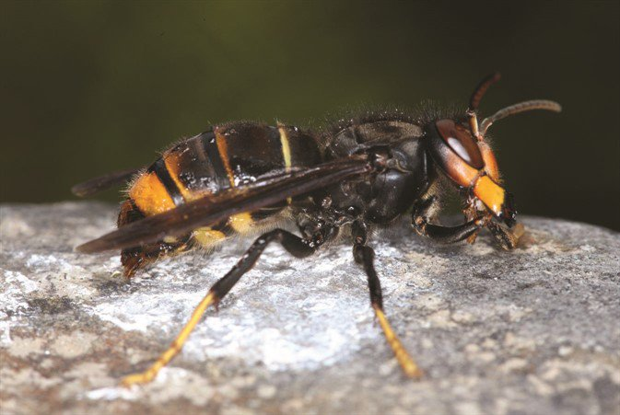
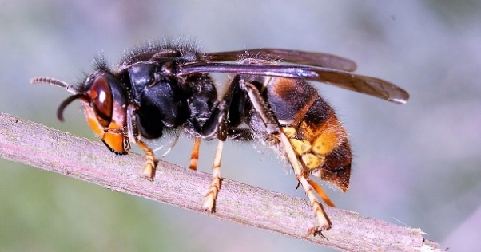

Picture from BBKA

copyright: John Feltwell

